MOSES: MOSES LISTENS TO GOD WHILE LEADING THE PEOPLE OUT OF EGYPT AND INTO THE PROMISED LAND
Exodus 14

MAIN POINT: God wants us to listen to Him and follow Him completely.

KEY VERSE: “The Lord will fight for you. Just be still.” Exodus 14:14

CRAFT IDEAS

Parting of the Red Sea Bible Craft Kit
www.orientaltrading.com, 48/2224
- Print Key Verse on address sticker labels, Avery #5160
- Glue craft together according the directions, using craft glue or glue dots.
- Moses Option: copy and color Moses below and use instead of the Moses that comes with the craft.
- Add Key Verse to picture front.

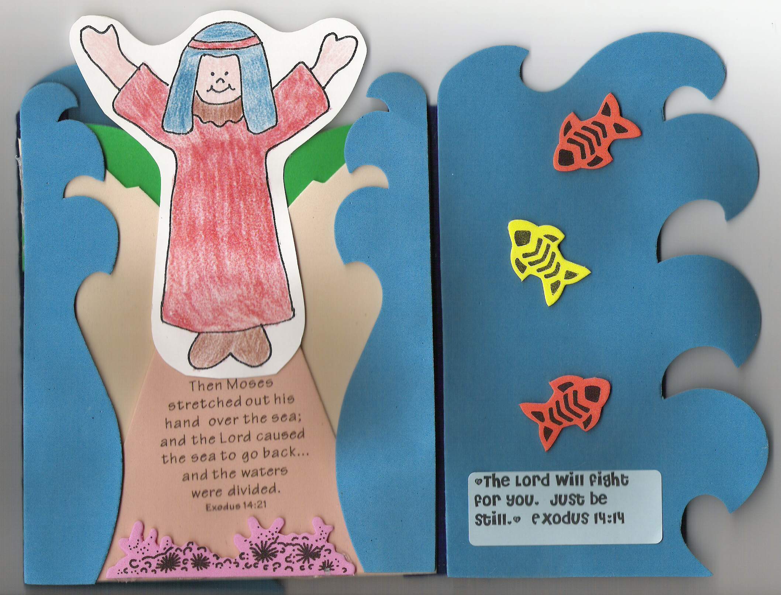
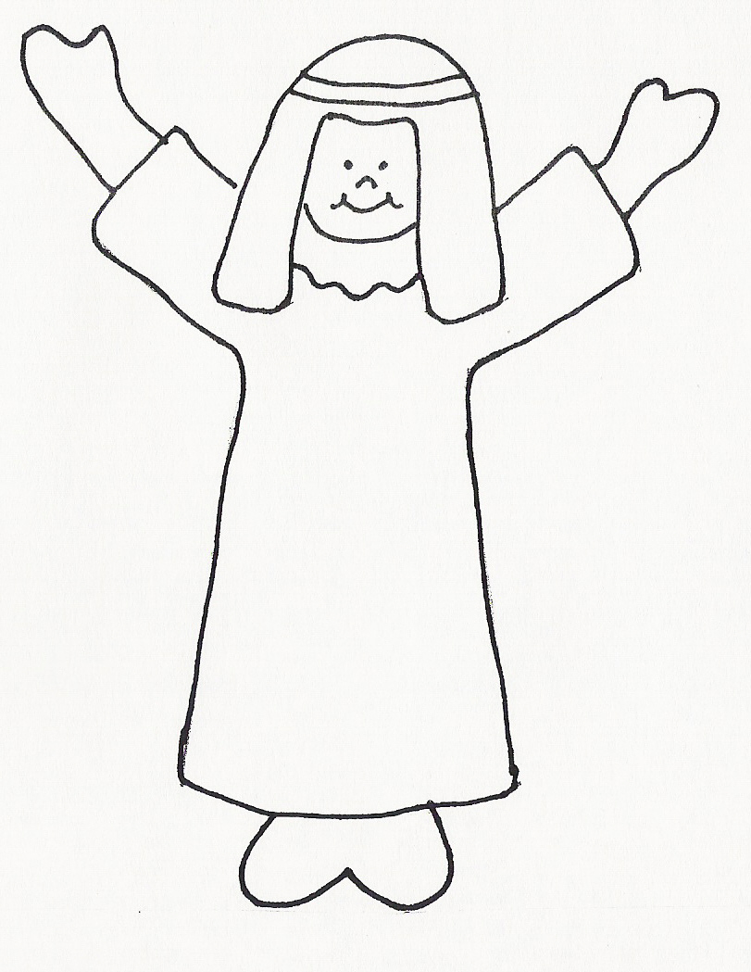

Optional idea: “Jesus is the Greatest” Treasure Map
(www.guildcraftinc.com)
- Color Treasure Map, using crayons, markers, or colored pencils.
- Print Key Verse and Main Point onto sticker address labels, Avery #5160 and apply to front of picture.
- Glue adhesive backed jewels in “Treasure Chest” for added fun.


